Problem-1: Write a C++ program to create and display a singly linked list.(Traversing)

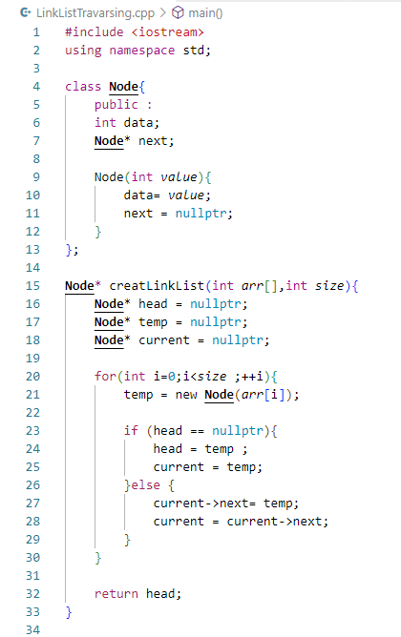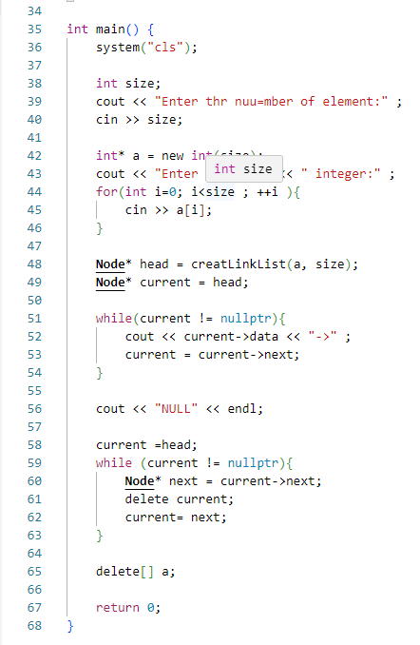Code:

Output:

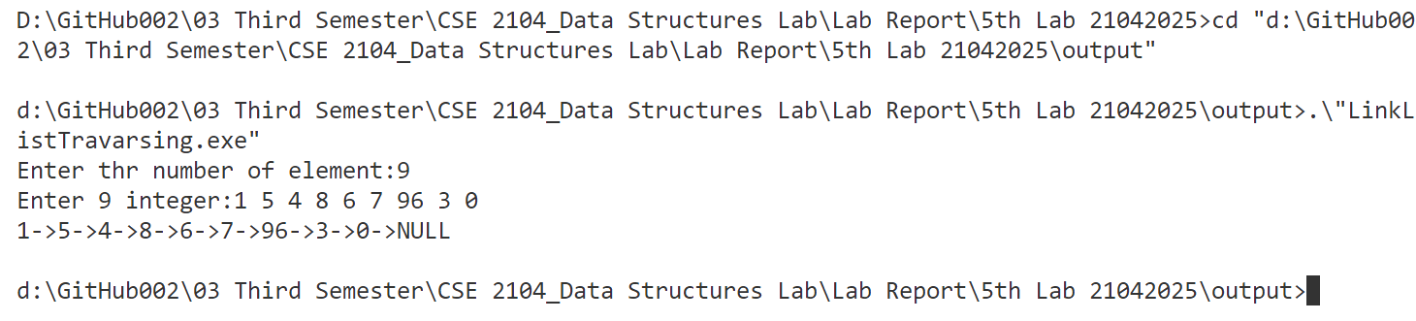

Problem-2: Write a C++ program to create and search an element in a singly linked list.

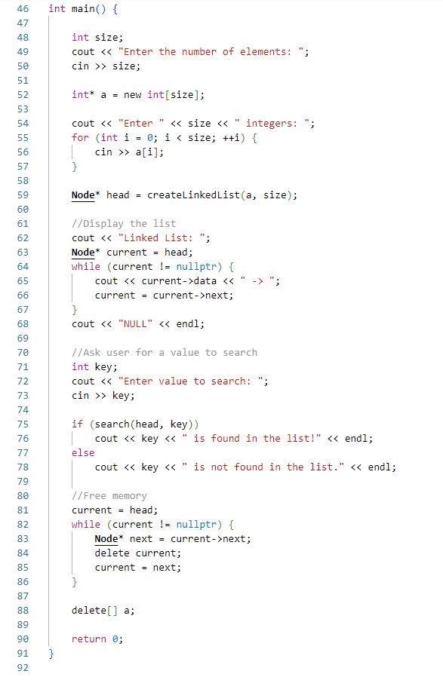Code:

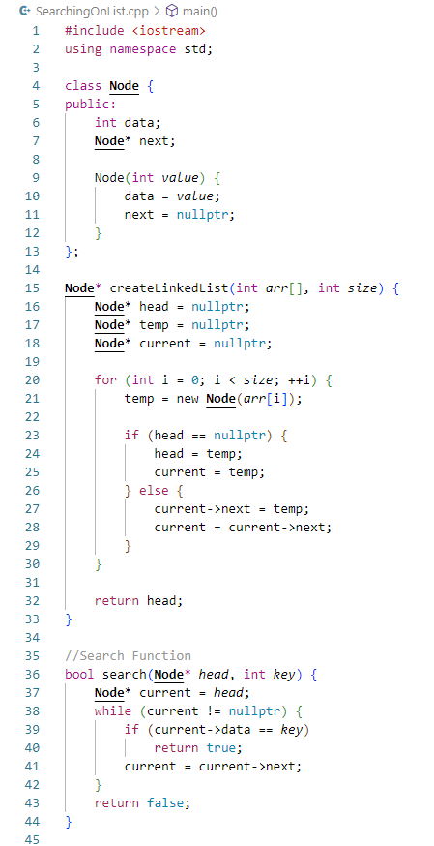

Output:

